Date: JUN 04 2021 File: C:\Karapetyan\18498 Защита от птиц и Крепление аккумулятора\03_program\1.5\18498_1.5001.NST

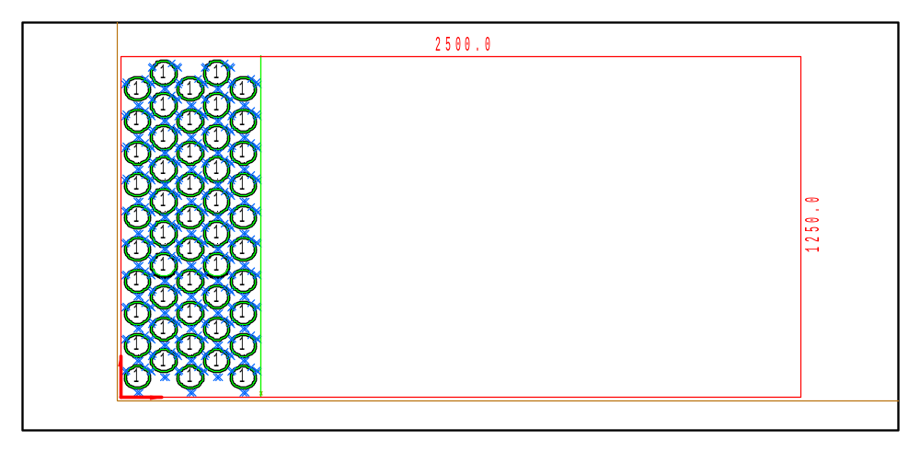

PART INFO
NC File Name: Ê!Å;Ä2QÅ8_1.5001nËÍ
Draft no.: | Version:
Order no.: | Description:
SHEET Number of sheets: 1
Material: Steel | Sheet size: 2500 X 1250 | T= 1.5
No. of parts: 50 | Part size:
Part weight: | Sheet weight: 36.56 kg
MACHINE:
MODEL: ML3015EX |  | Con. name: SPCC |  | Table name: ML45CF_R_EX
Gas: O2 | Lens: 7.5 Inches |  | Nozzle diameter: 1.7
Speed: 4000 |  | Used laser power: 650 |  | Beam diameter (kerf): 0.24
PROGRAM
Number: 4174 | File size: 5467 | Programmer:
Notes:
JOB TIME (min:sec)
Travel: 00:33 | Cut: 10:41 | Pierce: 01:18
Travel way: 12875.2 mm | Cutting way: 1256 mm | Pierce Qty.: 100
Total time: 12:32

 | Part name | DX | DY | QTY
1 | Ê#Å;ÌÌpËÍ | 102.4 | 103.4 | 50

